**S3 Bucket:**

it is basically used to store the data but it has more functionalities which will used on data other than storing it.

‘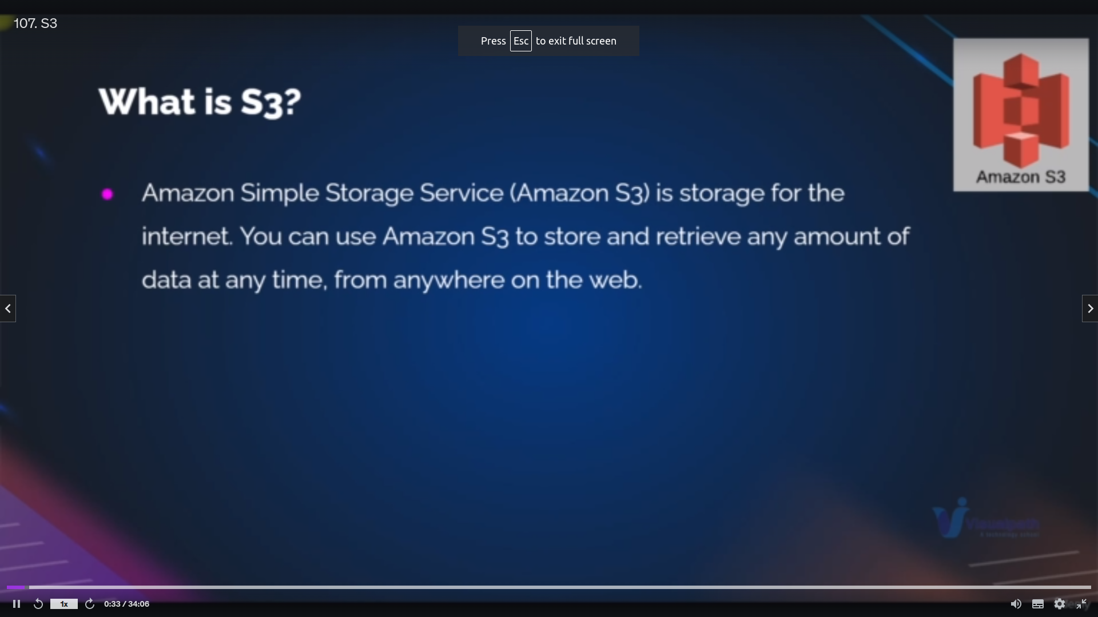s3 definiton

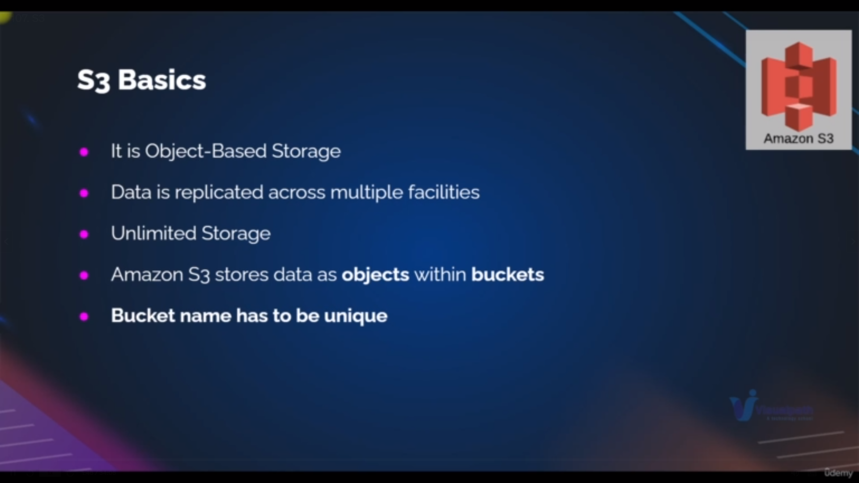s3 features it stores everything as object in it

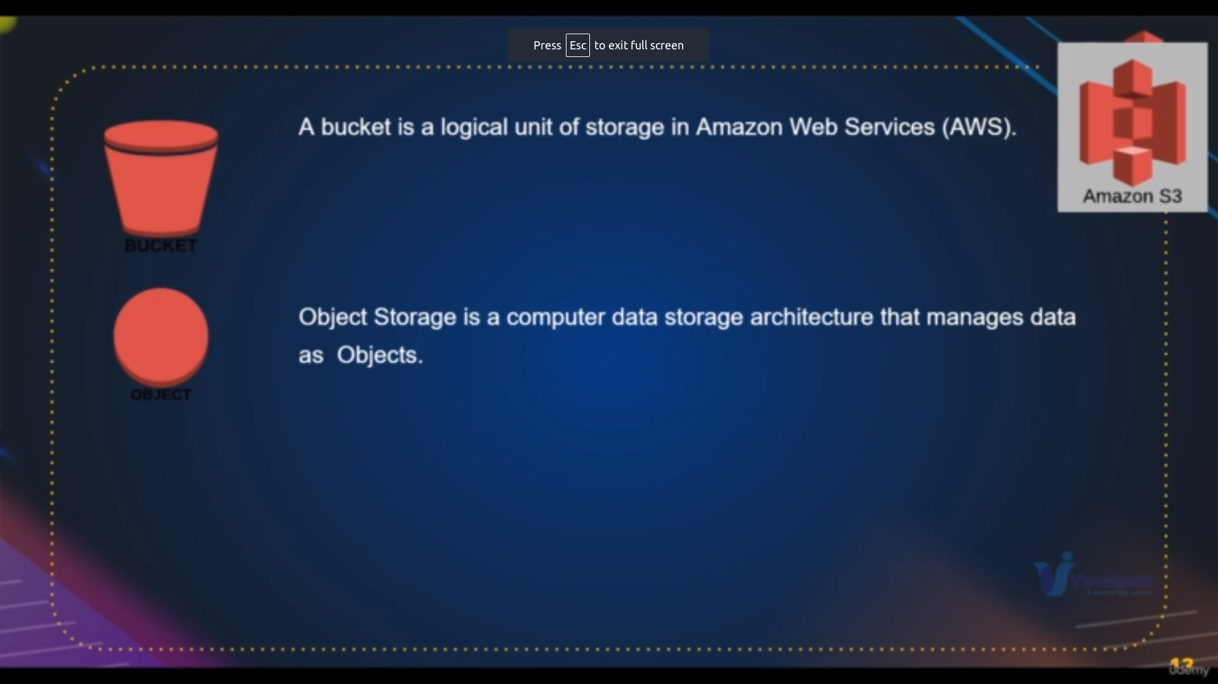description about object

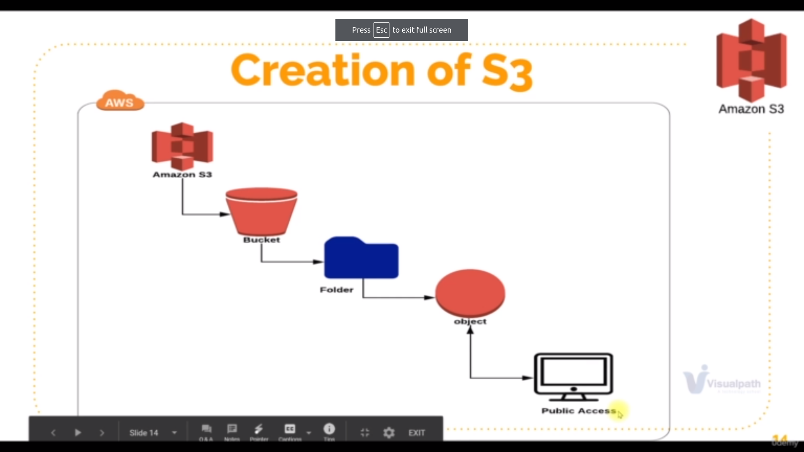flow of s3

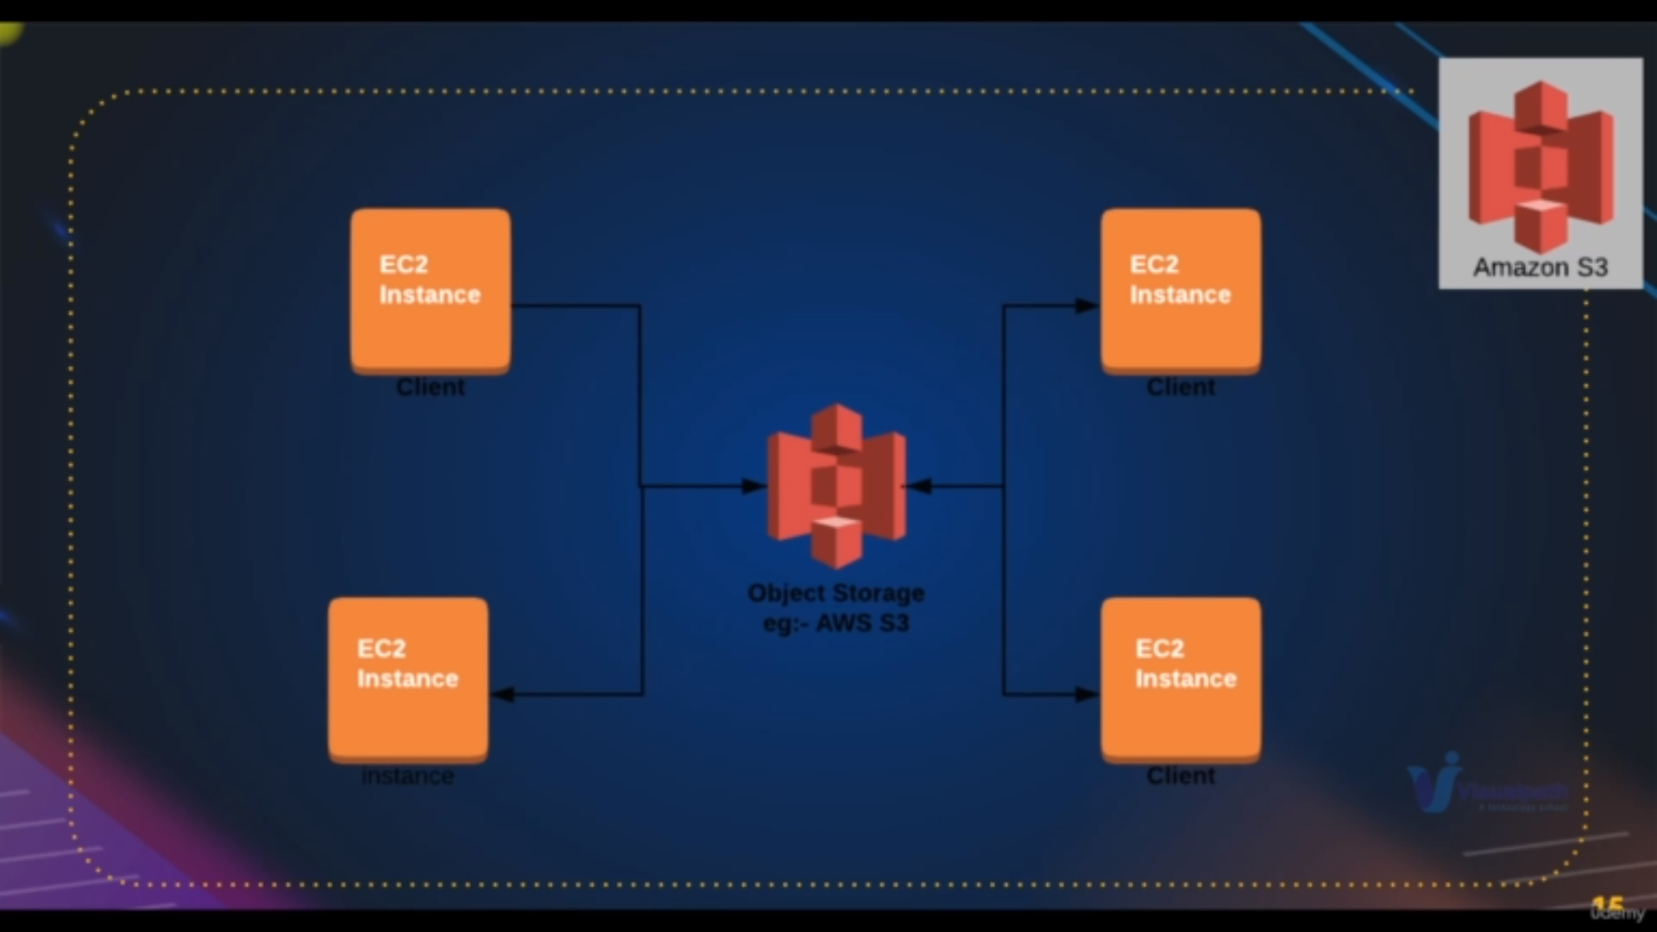uses of s3

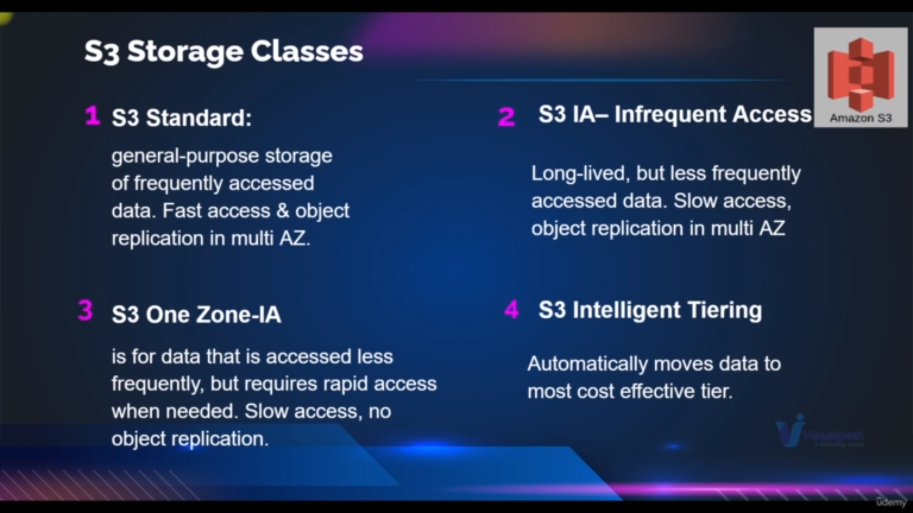types of s3(1)

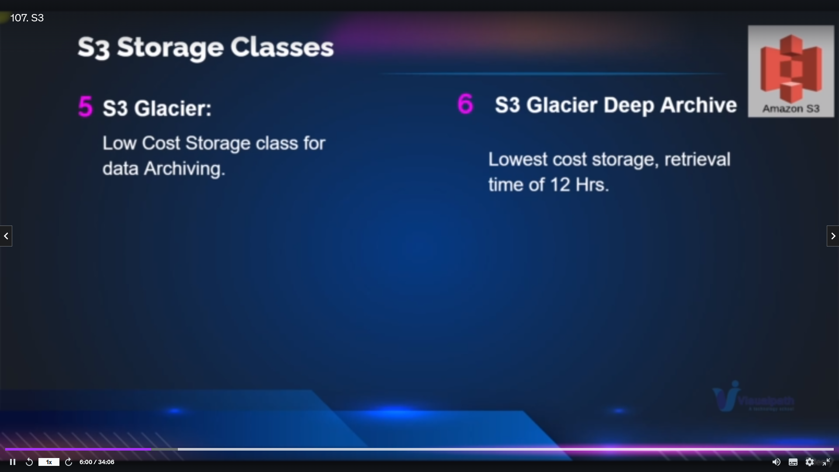types of s3(2)

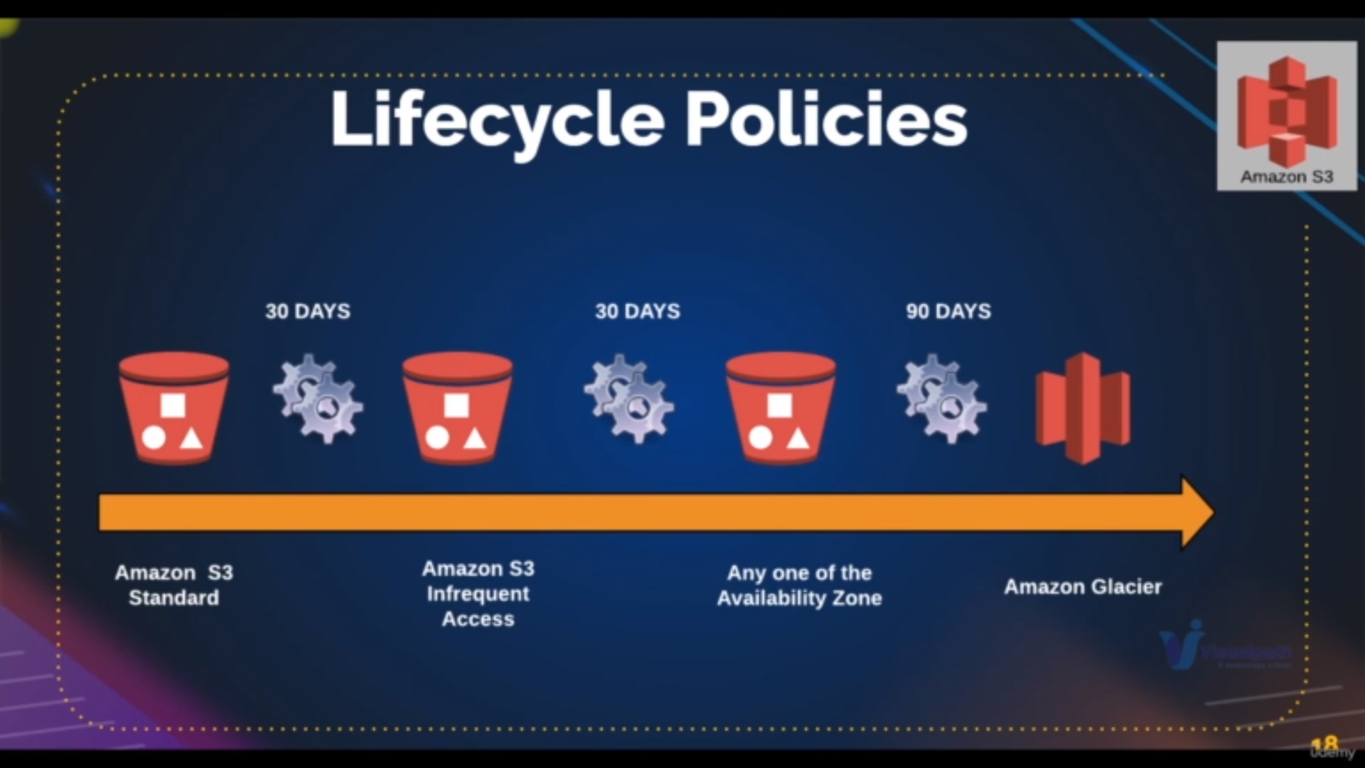we can also set time to change the bucket type using lifecycle policies

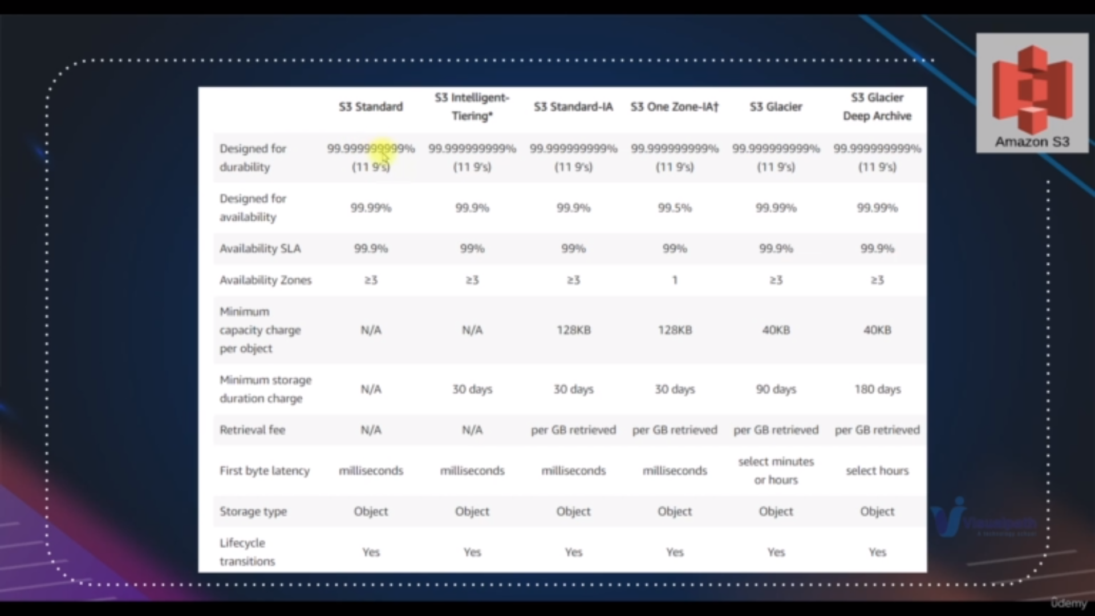details of different bucket type

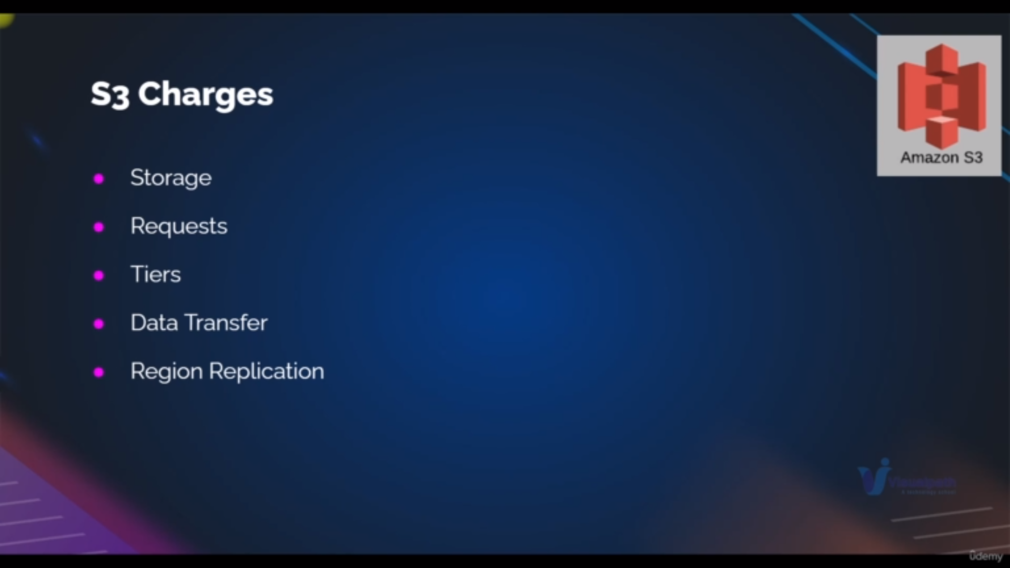charges of s3

**Practical:**

**Steps:**

**path:** search for s3 and click on s3

**step1:** click on create s3 bucket[it must be unique]

**step2**: write the bucket name and select region[defaultly it is accessible in all region

but for latency issues we are giving the priority region]

**step3**:.check the block all public access [Generally whatever we upload it is private only if you want to make that public before we have to uncheck this and after we have to make uploaded items public]

**step4**:bucket versing is in enable mode [this makes we go for previous version]

**step5**: click on create bucket

**step6**: click on created bucket

**step7**: click on upload

**step8**: upload the objects

**Make public acess:**

by default we cannot make the object public first we have to make sure that is ACL’s are in public accessible

**step1**:Go to the bucket

**step2**:click on permission tab

**step3**:click on edit for block public acess {bucket settings}

**step4**: uncheck the block all public access and save changes

**step5**: go to objects and click on it

**step6**: click on object action and click on make public access

[make public access is disabled whenever we do step3 and step4 only it becomes enables and then we make public]

**Features:**

**Hosting a static website :**

step1: go to the bucket and click on upload and click on add folder

step2:do the step3 and step4 from make public access

step3:go to the object tab select all file which are related to website

step4: click on actions and click on make public access

step5: click on properties tab

step6: click on edit of statictype webhosting as enable and mention index page and error page and save chages

step7: copy the bucket endpoint[url] and paste it on chrome it will show

**Bucket Versioning:**

**we can have the delete things safely**

prevquisite make some changes for existing files and upload it again

then the file override is by this file

step1: click on object there find two version of your file

step2:form there download previous version

step3: upload it again

Even if you delete a bucket the delete marker will be there becos of versioning enable

if you want to know on object tabe click on list all versions

then youll find all version of it if you delete this it will peremanetly gone

**Lifecycle rules:**

**we can change to one type of bucket to another with some time period**

step1:go to management tab and click on create life cycle rule

step2: write **lcr** name and check  **lcr** actions

step3:add the transition [which of storage class we have to change and on what no of days it will be changed]

step4:enter how many days that versioning is enable mode and after that it will disabled

step5:enter prefix and click create lcr

**Replication rule :**

**when we want one buckdata to another data we have to make to replication rule**

step1:on management tab click on create replcation rule

step2: write the name of replication rule

step3: choose destination bucket

we can also have choice of bucket type

step4: click on save

**Cleanup:**

if we delete directly bucket it wont be deleted you have change the cofiguaration as it is and delete all objects in the bucket